AI-Based Early Alzheimer’s Detection and Cognitive Assistance using Deep Learning

Abstract - Alzheimer's disease is a progressive neurodegenerative disorder that significantly affects memory, cognitive abilities, and daily functioning, making early diagnosis essential for effective treatment and improved quality of life. However, conventional diagnostic methods rely heavily on expert interpretation of MRI and CT brain scans, which can be time-consuming and prone to human error. To address these challenges, this project proposes an AI-based early Alzheimer's detection and cognitive assistance system using deep learning. The proposed system employs Convolutional Neural Networks (CNN) to automatically analyze MRI brain images and accurately classify different stages of Alzheimer's disease. An EfficientNetB0-based transfer learning model is used for feature extraction and classification of four stages/classes of Alzheimer’s disease. Image preprocessing techniques, including resizing, normalization, and data augmentation, are applied to enhance model performance and prediction accuracy. In addition to disease detection, the system provides intelligent cognitive assistance through medication reminders, appointment scheduling, face recognition for identity support, GPS-based patient tracking, memory training exercises, and real-time alerts for caregivers and healthcare professionals. A user-friendly web application integrates these features with a centralized doctor dashboard for continuous patient monitoring and healthcare management with role-based authentication, patient information management, REST APIs, and MongoDB Atlas for centralized data management. Experimental results demonstrate improved diagnostic accuracy, enhanced patient safety, reduced caregiver burden, and efficient healthcare support. By integrating deep learning with intelligent patient assistance, the proposed system offers a scalable, cost-effective, and reliable solution that supports early clinical decision-making, promotes patient independence, and contributes to improved healthcare outcomes.
Index Terms - Artificial Intelligence (AI), Machine Learning (ML), Deep Learning, Alzheimer's Disease Detection, Convolutional Neural Networks (CNN), EfficientNetB0, Transfer Learning, MRI Analysis, Cognitive Assistance, Face Recognition, GPS Tracking, Healthcare Monitoring.

- INTRODUCTION
Alzheimer's disease is a progressive neurological disorder that affects memory, thinking ability, and daily activities, making early diagnosis essential for effective treatment and better patient care. However, traditional diagnosis mainly depends on expert analysis of MRI brain scans, which can be time-consuming and may delay early intervention. This creates the need for an intelligent system that can assist healthcare professionals in detecting the disease accurately and efficiently. This project proposes an AI-based Alzheimer's detection and cognitive assistance system using Deep Learning. The system employs Convolutional Neural Networks (CNN) to analyze MRI brain images and classify different stages of Alzheimer's disease with EfficientNetB0 employed through transfer learning for feature extraction and classification. Image preprocessing techniques such as resizing, normalization, and data augmentation are applied to improve prediction accuracy. The system also integrates a healthcare application with Doctor and Caregiver dashboards, role-based authentication, REST APIs, and MongoDB Atlas for patient information management and cognitive assistance. In addition to disease detection, the system provides features such as medication reminders, memory training, face recognition, GPS tracking, and real-time alerts for caregivers. By integrating AI with a user-friendly healthcare application, the proposed system supports early diagnosis, enhances patient safety and independence, and improves overall healthcare management.

Objectives of the project
1. To achieve early-stage Alzheimer’s disease detection and classification using deep learning-based MRI brain image analysis and transfer learning techniques.
2. To maintain intelligent patient healthcare management through automated reminders, real-time activity monitoring, and doctor–caregiver coordination systems.
3. To ensure reliable cognitive support using machine learning–based assistance and face recognition techniques for memory enhancement and identity verification.
4. To develop a smart healthcare monitoring system with GPS tracking, anomaly detection, alert generation, and centralized analytics for continuous patient supervision.
Motivation for Automated Solutions

- Alzheimer's disease is one of the fastest-growing neurological disorders, making early detection essential to improve patient outcomes and quality of life.
- Traditional diagnosis relies on manual interpretation of MRI brain scans, which is time-consuming, requires specialists, and may delay treatment.
- Early-stage symptoms are often mild and difficult to identify, leading to late diagnosis when the disease has already progressed significantly.
- Recent advancements in Artificial Intelligence and Deep Learning, particularly Convolutional Neural Networks (CNN), enable accurate and automated analysis of brain images for early disease detection.
- Alzheimer's patients require continuous support for daily activities such as medication reminders, memory assistance, identity recognition, and location tracking to ensure safety and independence.
- Integrating AI-based disease detection with cognitive assistance and caregiver monitoring into a single intelligent system improves healthcare support, reduces caregiver burden, and enables better clinical decision-making.

- LITERATURE SURVEY
This literature survey reviews recent research on AI- and Deep Learning-based systems for Alzheimer's disease detection and cognitive assistance, grouped by methodological approach while highlighting their strengths and common limitations.
Deep Learning-Based Alzheimer's Disease Detection
Pasqualina Perna et al. [1] discussed the role of Artificial Intelligence in detecting neurocognitive disorders using MRI, EEG, biomarkers, and speech data. The study emphasizes early diagnosis and patient monitoring but faces challenges such as dataset heterogeneity, limited clinical validation, and ethical concerns.
Juan Zhou et al. [3] proposed a hybrid model combining 3D-CNN and Video Swin Transformer for Alzheimer's diagnosis from MRI images. The model achieves high classification accuracy but requires large datasets, high computational resources, and extensive clinical validation.
Parthasarathi Pattnayak et al. [5] introduced a hybrid AI framework using DenseNet and machine learning classifiers for Alzheimer's detection. Although the model improves diagnostic performance, it has high computational complexity and limited explainability.
CNN-Based MRI Image Classification
Ghata Mehta et al. [6] presented a Multi-CNN ensemble model for early Alzheimer's detection using MRI images. The ensemble improves classification accuracy but increases computational cost and depends on high-quality MRI datasets.
A. M. El-Assy et al. [12] proposed a novel CNN architecture for multi-class Alzheimer's classification. The model extracts deep spatial features effectively but requires large balanced datasets for consistent performance.
Falah Sheikh et al. [16] reviewed CNN-based medical imaging techniques for Alzheimer's diagnosis. The study demonstrates the effectiveness of deep learning but highlights challenges in dataset generalization and real-world clinical deployment.
AI-Based Cognitive Assistance Systems
Priyanka K. et al. [7] developed an LSTM-based assistance system providing medication reminders, tracking, and personalized care for Alzheimer's patients. The approach improves patient support but lacks a unified framework and raises privacy concerns.
Samah A. Z. Hassan [13] proposed MemorySona, a mobile application integrating deep learning with memory training and reminder features. The system enhances patient assistance but requires larger datasets and further clinical testing.
Kiruthika V. R. et al. [15] introduced an AI-based smart assistant using LSTM, Random Forest, SVM, and LightGBM for patient monitoring and activity prediction. While effective, the system depends on continuous user interaction and raises concerns regarding data privacy.
AI Reviews and Healthcare Monitoring
Subramanian Ganesan [10] presented a comprehensive review of AI and Machine Learning techniques for Alzheimer's detection using MRI, PET, and biomarkers. The review concludes that hybrid and multimodal approaches improve diagnostic accuracy but require standardization and clinical validation.
S. Rathore et al. [17] compared traditional Machine Learning algorithms such as SVM, Random Forest, and Logistic Regression for Alzheimer's diagnosis. Although these models perform well with structured data, they rely on manual feature extraction and struggle with high-dimensional medical images.
Wenli Zhang et al. [20] proposed a deep CNN model for Alzheimer's detection using MRI images with data augmentation techniques. The model achieved high classification accuracy but requires large datasets and significant computational resources while addressing ethical and privacy challenges.

TABLE I: OVERVIEW OF EXISTING AI-BASED ALZHEIMER'S DISEASE DETECTION AND COGNITIVE ASSISTANCE SYSTEMS
Article | Overview
[1] | AI-based system for detecting neurocognitive disorders using MRI, EEG, biomarkers, and speech data. Supports early diagnosis and monitoring but suffers from dataset heterogeneity and limited clinical validation.
[2] | AI-driven caregiver support system using NLP, machine learning, and wearable devices. Provides personalized monitoring but depends on smart devices and requires explainable AI.
[3] | Hybrid 3D-CNN and Video Swin Transformer model for Alzheimer's detection from MRI images. Achieves high accuracy but requires large datasets and high computational resources.
[4] | CNN-based facial expression analysis for neurological disorder detection. Improves non-invasive diagnosis but is affected by limited datasets and lack of standardization.
[5] | Hybrid DenseNet and ML classifier framework for Alzheimer's diagnosis using MRI images. Improves accuracy but has high computational complexity and limited explainability.
[6] | Multi-CNN ensemble model for early Alzheimer's detection using MRI scans. Provides better classification accuracy but requires high-quality datasets and extensive validation.
[7] | LSTM-based intelligent assistance system providing reminders, tracking, and personalized care. Enhances patient support but faces privacy and integration challenges.
[8] | YOLOv11-based deep learning model for multi-stage Alzheimer's classification using MRI images. Delivers high accuracy but depends heavily on image quality and large datasets.
[9] | Qualitative study on caregiver burden in Alzheimer's care. Highlights emotional and financial challenges but lacks AI implementation and experimental validation.
[10] | Integrated deep learning framework combining DeepLabV3+, LeNet-5, and ResNeXt for multi-class Alzheimer's diagnosis. Improves classification but is affected by class imbalance.
[11] | Deep CNN model using MRI images and data augmentation for Alzheimer's detection. Achieves high accuracy but requires extensive training data and computational resources.
[12] | Novel CNN architecture for early Alzheimer's classification from MRI data. Extracts deep spatial features effectively but performance decreases with limited datasets.
[13] | MemorySona mobile healthcare application integrating deep learning diagnosis with memory training and reminders. Enhances patient assistance but requires further real-time clinical evaluation.
[14] | AI/ML-based prediction system using clinical and cognitive data for Alzheimer's diagnosis. Improves diagnostic accuracy but is limited by small sample size and lack of generalization.
[15] | AI-based smart assistant using LSTM, Random Forest, SVM, and LightGBM for patient monitoring. Improves safety but depends on continuous user interaction and raises privacy concerns.
[16] | Review of CNN-based medical imaging techniques for Alzheimer's diagnosis. Demonstrates strong diagnostic performance but requires broader clinical validation.
[17] | Comprehensive review of AI and ML techniques for early Alzheimer's detection using MRI, PET, and biomarkers. Highlights hybrid approaches but emphasizes the need for standardized datasets.
[18] | Deep learning-based Alzheimer's classification using MRI images. Improves accuracy over traditional ML methods but depends on high-quality imaging data.
[19] | CNN-based Alzheimer's detection framework with transfer learning and feature extraction. Achieves high accuracy but is prone to overfitting and lacks interpretability.
[20] | Review of Machine Learning techniques including SVM, Random Forest, and Logistic Regression for Alzheimer's diagnosis. Identifies limitations in manual feature extraction, data imbalance, and high-dimensional medical data.

Key Findings and Research Gaps

The reviewed literature on AI- and Deep Learning-based Alzheimer's disease detection and cognitive assistance systems reveals several important advancements, challenges, and research gaps in intelligent healthcare solutions:

- Improved Diagnostic Accuracy Using Deep Learning: Recent studies demonstrate that Convolutional Neural Networks (CNNs), DenseNet, 3D-CNN, and hybrid deep learning models achieve high accuracy in detecting and classifying Alzheimer's disease from MRI and CT brain images. These approaches significantly improve early diagnosis compared to traditional machine learning methods.
- Growing Integration of AI with Patient Assistance: Several researchers have extended AI-based diagnosis by integrating features such as medication reminders, cognitive training, face recognition, GPS tracking, and caregiver monitoring. However, most existing systems focus on either disease detection or patient assistance rather than providing a unified healthcare solution.
- High Computational Requirements: Advanced deep learning architectures require powerful GPUs, large memory, and extensive training datasets. These computational demands limit their deployment in resource-constrained healthcare environments and real-time applications.
- Limited Clinical Validation and Practical Deployment: Most proposed systems are evaluated using publicly available MRI datasets under laboratory conditions. Large-scale clinical validation and deployment in real healthcare environments remain limited, affecting the reliability and acceptance of these models.
- Dataset Quality and Generalization Challenges: Many studies rely on limited or imbalanced MRI datasets, leading to overfitting and reduced generalization across diverse patient populations. The absence of standardized and diverse datasets remains a major challenge for developing robust diagnostic systems.
- Need for an Integrated Healthcare Platform: Although existing research demonstrates high prediction accuracy, very few systems combine early Alzheimer's detection with cognitive assistance, patient monitoring, caregiver support, and doctor dashboards in a single platform. This creates the need for a comprehensive AI-based healthcare system that supports diagnosis, continuous monitoring, and effective patient management.

These findings highlight the need for an intelligent, scalable, and integrated Alzheimer's healthcare system that combines CNN-based MRI/CT image analysis with cognitive assistance, patient monitoring, caregiver support, and doctor dashboards. The proposed project addresses these research gaps by providing a unified AI-powered platform that enables early diagnosis, enhances patient safety and independence, reduces caregiver burden, and supports healthcare professionals in making faster and more reliable clinical decisions.

- METHODOLOGY

The proposed methodology consists of two major phases - Alzheimer's disease detection and cognitive assistance, integrated into a smart AI-based healthcare system. The system combines deep learning-based medical image analysis with intelligent patient support features through a web/mobile application, enabling early diagnosis and continuous healthcare monitoring.

Data Collection and Processing

The data collection stage involves acquiring MRI brain scan images from publicly available medical datasets such as Kaggle and other healthcare repositories. These datasets contain labeled brain images representing different stages of Alzheimer's disease, including Non-Demented, Mild, Moderate, and Severe cases.
To prepare the collected data for deep learning, the following preprocessing operations are performed:

- Image Resizing: All MRI and CT images are resized to 224 × 224 pixels to match the input size required by the Convolutional Neural Network (CNN).

- Image Normalization: Pixel intensity values are normalized to the range 0–1 to improve training stability and model convergence.

- Data Cleaning : Corrupted, duplicate, and low-quality images are removed to maintain dataset consistency and improve prediction reliability.

- Image Enhancement: Contrast enhancement techniques are applied to improve the visibility of important brain structures and disease-related features.

- Dataset Splitting: The processed dataset is divided into training, validation, and testing sets to evaluate model performance effectively.

This preprocessing framework ensures that all MRI and CT images are transformed into high-quality, standardized inputs for accurate Alzheimer's disease classification.

Image Processing

This preprocessing pipeline improves image quality and enables reliable Alzheimer's disease detection.The image preprocessing pipeline consists of the following steps:

- Image Resizing: All MRI and CT images are resized to 224 × 224 pixels to ensure uniform input dimensions.
- Normalization: Pixel values are normalized to the range [0,1] by dividing by 255 to improve CNN performance.
- Noise Reduction: Filtering techniques are applied to remove unwanted noise while preserving essential brain structures.
- Contrast Enhancement: Contrast enhancement is performed to highlight abnormalities and improve feature extraction.
- Feature Extraction: The CNN automatically extracts meaningful spatial features from brain images for accurate disease classification.
Data Augmentation

To improve model generalization and reduce overfitting, the following data augmentation techniques are applied:

- Rotation: Random rotations within ±15°.
- Horizontal Flip: Applied where appropriate to increase dataset diversity.
- Zoom: Random zoom between 0.9× and 1.1×.
- Brightness Adjustment: Pixel intensity variation to simulate different imaging conditions.
- Width and Height Shift: Small translations to improve robustness against image alignment variations.

These augmentation techniques increase dataset diversity while preserving important medical features, resulting in improved CNN performance.

SYSTEM ARCHITECTURE
Figure 1: System Architecture
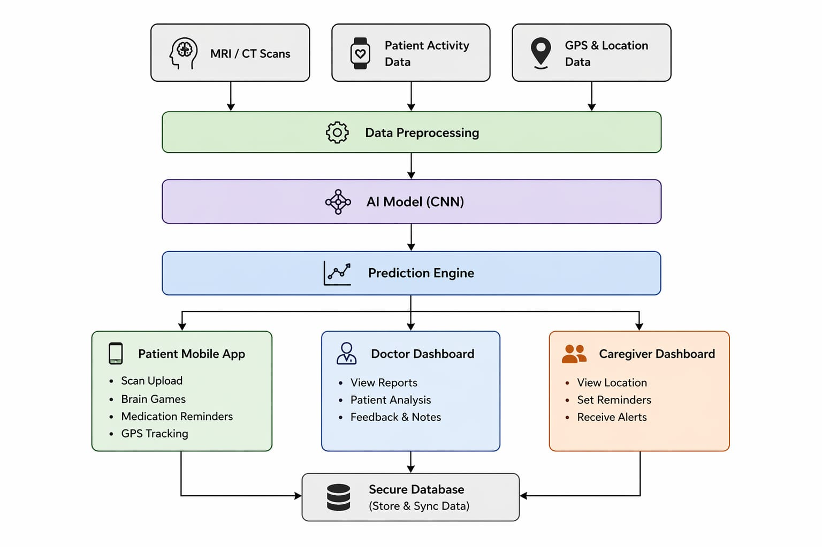
The system architecture of the AI-Based Early Alzheimer's Detection and Cognitive Assistance using Deep Learning is designed as an integrated healthcare framework that combines deep learning-based disease diagnosis with intelligent patient assistance. The architecture enables seamless interaction between image acquisition, preprocessing, disease prediction, cognitive support, patient monitoring, and doctor dashboards. It provides an efficient platform for early Alzheimer's diagnosis while supporting continuous patient care.
The architecture consists of two major input sources—MRI/CT brain scan images and patient healthcare information. Brain images undergo preprocessing before being analyzed by a Convolutional Neural Network (CNN) to classify Alzheimer's disease stages. Simultaneously, patient information is utilized by the cognitive assistance module to provide medication reminders, appointment scheduling, face recognition, GPS tracking, and emergency alerts. The prediction results and patient information are integrated into a centralized doctor dashboard for monitoring and decision-making.
The modular architecture allows easy integration of additional AI models, larger medical datasets, and future healthcare features. The separation of frontend, backend, and AI modules improves scalability, maintainability, and deployment across different healthcare environments.
The architecture also emphasizes data security and reliability. Patient records, scan images, and prediction results are stored in a secure centralized database with role-based access control and encryption to protect sensitive medical information. The frontend, backend, and AI modules communicate through REST APIs, so the CNN model can be updated or replaced without affecting the rest of the system. The backend also handles real-time services such as GPS tracking, reminder notifications, and emergency alerts, which are sent instantly to caregivers and family members. Together, these features make the system a dependable, scalable solution for early Alzheimer's detection and long-term cognitive care.

Stage 1: Data Input and Preprocessing
- Users upload MRI or CT brain scan images through the web/mobile application.
- Brain images undergo preprocessing steps such as resizing, normalization, contrast enhancement, noise reduction, and data augmentation.
- Patient information is securely stored for cognitive assistance and healthcare monitoring.
- This stage ensures standardized and high-quality input for accurate disease prediction.
Stage 2: Alzheimer's Detection and Cognitive Assistance
- A Convolutional Neural Network (CNN) analyzes the preprocessed MRI/CT images to classify Alzheimer's disease into different stages.
- The cognitive assistance module provides medication reminders, appointment scheduling, memory training exercises, face recognition, and GPS-based patient tracking.
- An anomaly detection module continuously monitors patient activities and generates emergency alerts when abnormal behaviour is detected.
- Prediction results and patient status are integrated to provide comprehensive healthcare support.
Stage 3: Result Visualization and Deployment
- Disease prediction results are displayed through an interactive doctor dashboard along with patient history and health analytics.
- Caregivers and healthcare professionals receive real-time notifications and emergency alerts when necessary.
- The integrated healthcare application supports secure access, continuous monitoring, and centralized patient management.
- The complete system is deployed as a web-based healthcare platform, providing scalable, accessible, and reliable Alzheimer's diagnosis and patient assistance.

DATA FLOW DIAGRAM
Figure 2: Data Flow Diagram
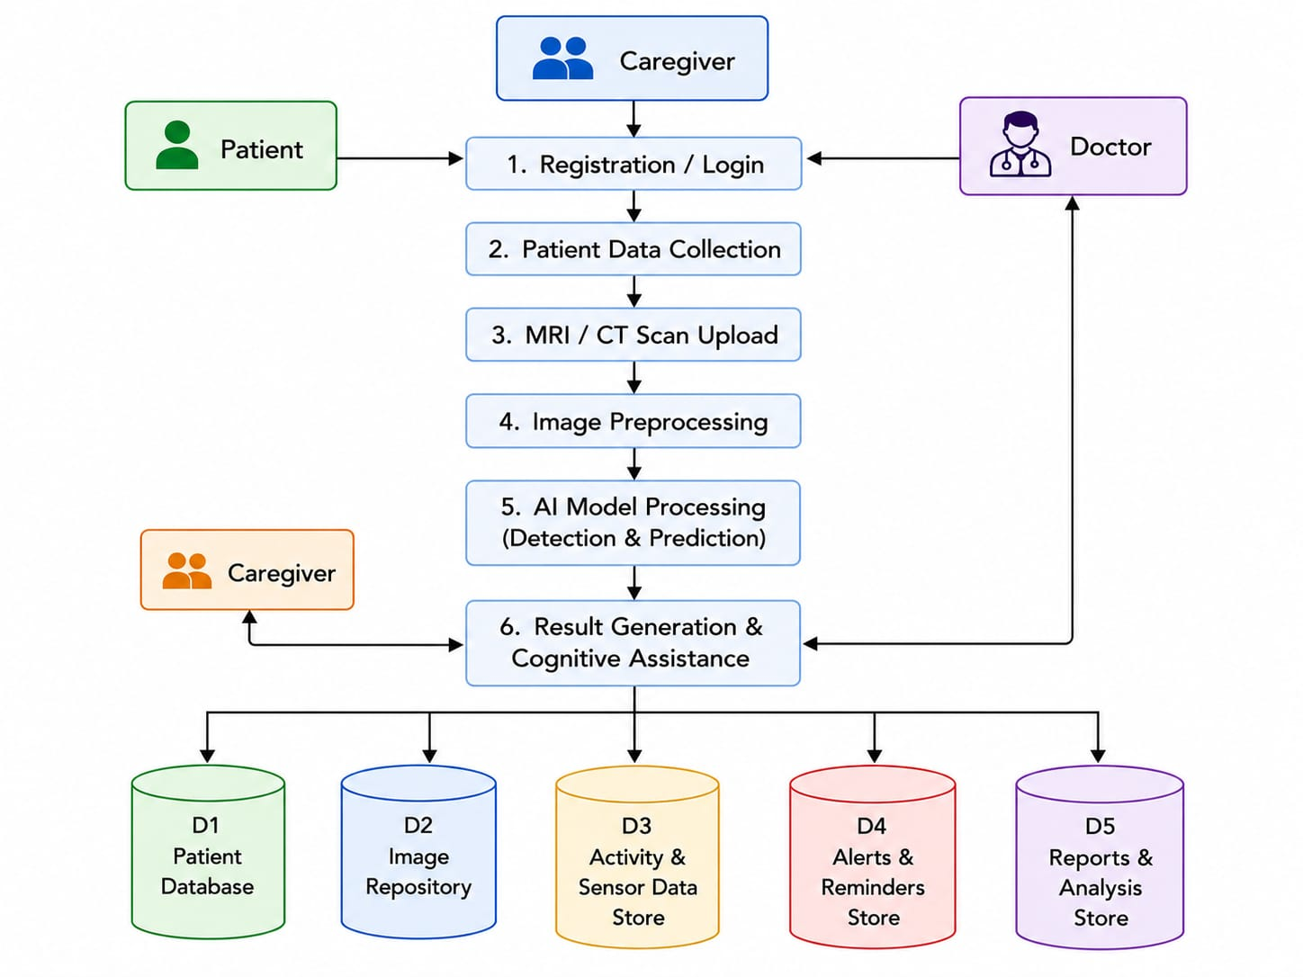
- COMPARATIVE STUDY
A comparative analysis was carried out to evaluate the proposed CNN-based Alzheimer's disease detection and cognitive assistance system against widely used machine learning and deep learning algorithms. The comparison is based on important performance parameters such as feature extraction, classification accuracy, precison, F1 Score, computational complexity, ability to process medical images, and cognitive assistance support.
Existing Work | Algorithm | Accuracy(%) | Precision(%) | Recall(%) | F1 Score(%)
MemorySona: Cognitive Health with Deep Learning |  | 88.36 | 89.96 | 89.50 | 90.03
  DenseNet121
A Deep Learning Model for Early Diagnosis of Alzheimer’s Disease | 3D-CNN + LR Video Swin Transformer | 92 | 96.5 | 91.0 | 90.9
A Multi-CNN Ensemble Method for Early Alzheimer’s Disorder | Multi-CNN Ensemble |  | 98.5 | 98.6 | 98.5
  99.43
  (3-class)
Machine Learning Techniques for Alzheimer’s Disease Diagnosis | SVM and RF | 91.3 | 90.8 | N/A | N/A
Proposed System | EfficientNetB0  CNN | 96.60 | 94.13 |  | 91.54
  93.12

Performance Comparison
- Support Vector Machine (SVM): SVM performs well on structured datasets but requires manual feature extraction. Its performance decreases when handling complex MRI images and large datasets.
- Random Forest (RF): Random Forest provides better classification than traditional statistical methods but depends on handcrafted features and cannot effectively capture deep spatial patterns in medical images.
- Logistic Regression (LR): Logistic Regression is computationally efficient but is mainly suitable for linearly separable data and performs poorly for complex Alzheimer's image classification.
- DenseNet: It automatically extracts deep image features and provides high classification accuracy. However, it requires higher computational resources and focuses only on disease detection without patient assistance.
- Proposed CNN-Based System: The proposed CNN EfficientNetB0 model automatically extracts image features from MRI scans, providing accurate Alzheimer's stage classification. Unlike existing algorithms, it integrates intelligent cognitive assistance features including medication reminders, appointment scheduling, face recognition, GPS-based patient tracking, emergency alerts, and a centralized doctor dashboard, making it a comprehensive healthcare solution.

- CONCLUSION

The proposed AI-Based Early Alzheimer's Detection and Cognitive Assistance System demonstrates the effective application of deep learning techniques for the early diagnosis of Alzheimer's disease and continuous patient support. By analyzing MRI and CT brain images using a Convolutional Neural Network (CNN), the system accurately classifies different stages of Alzheimer's disease while providing intelligent cognitive assistance features such as medication reminders, memory training, face recognition, GPS-based patient tracking, and emergency alerts. The integrated doctor dashboard enables efficient patient monitoring and supports timely clinical decision-making. An EfficientNetB0-based transfer learning model was implemented for Alzheimer’s disease classification and achieved an observed accuracy of 96.60%, with a precision of 94.13%, recall of 93.12%, and F1-score of 91.54%.
Experimental evaluation shows that the system delivers reliable predictions, user-friendly operation, and effective healthcare assistance. Overall, the proposed solution offers a scalable and cost-effective platform for early Alzheimer's diagnosis, improved patient safety, and enhanced caregiver support.
Looking ahead, several improvements can further enhance the system’s functionality and scalability:
Incorporating larger and more diverse MRI/CT datasets and advanced deep learning architectures such as Vision Transformers (ViT) can further improve diagnostic accuracy and robustness. Developing a dedicated mobile application will enable patients, caregivers, and healthcare professionals to access diagnosis, monitoring, and alerts anytime and anywhere. Integrating wearable sensors and IoT devices can facilitate real-time health monitoring, activity tracking, and early detection of abnormal patient behavior. Implementing stronger security measures such as data encryption, secure authentication, and compliance with healthcare standards (HIPAA/GDPR) will ensure patient data privacy and confidentiality. Collaborating with hospitals and healthcare institutions for real-world clinical validation can improve system reliability, scalability, and adoption in practical healthcare environments.

REFRENCES

[1] Pasqualina Perna, Alessandra Claudi, Fabrizio Stasolla, Raffaele Nappo. The Role of Artificial Intelligence in the Detection and Diagnosis of Neurocognitive Disorders. MDPI Journal, Vol. 13(1), 2026.

[2] Syeda Umme Salma, Chandra Rekha Renduchintala, Isa Siddique, Evelina Sterling, Sweta Sneha. AI-Driven Mental Health Support for Caregivers of Individuals With Alzheimer Disease. JMIR Mental Health, 2026.

[3] Juan Zhou, Yiming Wei, Xiong Li, Weiqiang Zhou, Ruiyang Tao, Yi Hua, Hongwei Liu. A Deep Learning Model for Early Diagnosis of Alzheimer’s Disease Combined with 3D CNN and Video Swin Transformer. Scientific Reports, 2025.

[4] Shania Yoonesi, Ramila Abedi Azar, Melika Arab Bafrani, Shayan Yaghmayee, Haniye Shahavand. Facial Expression Deep Learning Algorithms in the Detection of Neurological Disorders. BioMedical Engineering OnLine, 2025.

[5] Parthasarathi Pattnayak, Tulip Das. Enhanced Hybrid AI-Based Framework for Improving the Detection and Diagnosis of Alzheimer’s Disease. IEEE, 2025.

[6] Ghata Mehta, Nitya Jani, Himanshu Gajera, Rajendra Choudhary. A Multi-CNN Ensemble Method for Early Diagnosis of Alzheimer’s Disease Using MRI Imaging. International Conference on Artificial Intelligence and Machine Vision (AIMV), IEEE, 2025.
[7] Priyanka K, Vikas Benhur Chitla, Aman Aftab, Sumanth Kamath. LSTM-Based Assistance for People with Alzheimer’s Disease. International Conference on Intelligent and Innovative Technologies in Computing, Electrical and Electronics (IITCEE), IEEE, 2025.

[8] Wided Hechkel, Rim Missaoui, Abdelhamid Helali. Early Diagnosis of Alzheimer's Disease Using YOLOv11 Deep Learning Model in MRI Scans. IEEE 22nd International Multi-Conference on Systems, Signals & Devices (SSD), 2025.

[9] Wenxia Zhang, Wenting Xu, Junzhi Duan, Junyu Tang, Qunli Zhu, Xifeng Pi, Jing Huang. Exploring how caregivers of people with Alzheimer’s disease experience role captivity. International Psychogeriatrics, Elsevier, 2025.

[10] Emanuel Raju Vinukonda & B. N. Jagadesh. An integrated deep learning model for early and multi-class diagnosis of Alzheimer's disease from MRI scans. Scientific Reports, 2025.

[11] Wenli Zhang, Yifan Li, Wentao Ren, Bo Liu. Artificial Intelligence Technology in Alzheimer’s Disease Research. Intractable & Rare Diseases Research Journal, 2025.

[12] A. M. El-Assy, Hanan M. Amer, H. M. Ibrahim, and M. A. Mohamed. A novel CNN architecture for accurate early detection and classification of Alzheimer’s disease using MRI data. Scientific Reports, 2024.

[13] Samah A. Z. Hassan. MemorySona: Illuminating Cognitive Health with Deep Learning – A Mobile Medical App for Alzheimer’s Patients. 2024 6th International Conference on Computing and Informatics (ICCI), IEEE, 2024.

[14] Wenxia Zhang, Wenting Xu, Junzhi Duan, Junyu Tang, Qunli Zhu, Xifeng Pi, Jing Huang. Exploring how caregivers of people with Alzheimer’s disease experience role captivity: A qualitative study. International Psychogeriatrics, Elsevier, 2024.

[15] Kiruthika V R, NirmalaDevi J. AI-Based Smart Assistant System for Alzheimer Patients. 2024 5th International Conference on Electronics and Sustainable Communication Systems (ICESC), IEEE, 2024.

[16] Falah Sheikh, Ahmed Al Marouf, Jon George Rokne, Reda Alhajj. Deep Learning-Based Diagnosis of Alzheimer’s Disease Using Medical Imaging. Diagnostics Journal, 2024.

[17] Subramanian Ganesan. Early Detection of Alzheimer’s Disease Using Artificial Intelligence and Machine Learning: A Comprehensive Review. VIT University, 2024.

[18] Wenli Zhang, Yifan Li, Wentao Ren, Bo Liu. Artificial Intelligence Technology in Alzheimer’s Disease Research. Intractable & Rare Diseases Research, 2023.

[19] A. Khan, S. Hussain, M. Usman, et al., Deep Learning-Based Classification of Alzheimer’s Disease Using MRI Data, IEEE Access, 2023.

[20] S. Rathore, M. Habes, M. A. Iftikhar, Machine Learning Techniques for Alzheimer’s Disease Diagnosis: A Review, Elsevier (Journal of Neuroscience Methods), 2023.

